This activity aims to provide students with a deeper understanding of the Central Limit Theorem in an active and engaging way.

1. Have students read the top of the page and then answer the first question on their sheet. Consider doing a [Think, Pair, Share](http://www.adlit.org/strategies/23277/).

2. Show students the string of numbers (page 2) for one minute, and then hide the values and give them 30 seconds to recall as many numbers as possible. Show them the string again and have them write down how many numbers, in order, they got correct.

3. Show students the string of letters (page 3) for one minute, and then hide the letters, and then give them 30 seconds to recall as many letters as possible. Show them the string again and have them write down how many letters, in order, they got correct.

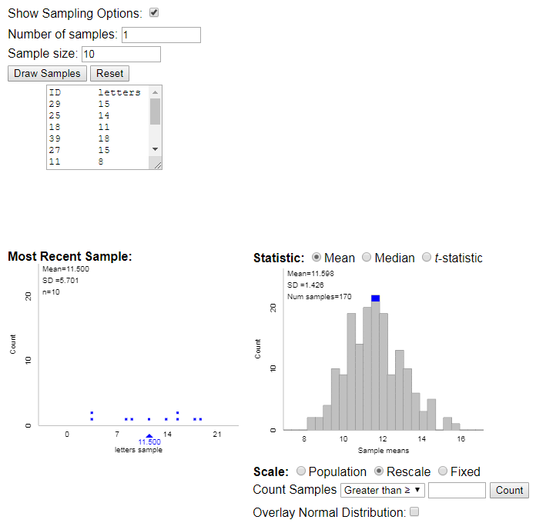4. Write all the students responses for each, separately, on the board, and have students find the mean and standard deviation using their graphing calculators and 1 Vars Stats.

5. Use <http://www.rossmanchance.com/applets/OneSample.html> to create the sampling distributions for your student “letters” data:

1. Clear the data in the box
2. Put in the data for your class, but write something like “letters” before then listing your class values
3. Press Use Data (this will assign your values an ID)
4. Below the box you should now see a histogram with the mean and standard deviation of your class data
5. Click on “Show Sampling Options” (on the right )
6. Take some time to show students the sampling distributions for the different sample sizes on their sheet (). Consider starting with one sample to show what is happening, and then increase the number of samples until they can see the normal distribution forming. Have students write the new mean and standard deviation for the sampling distributions on their sheets.

6. Have student work together to answer the two probability questions at the bottom of the second page.

5203718946409528371663489

LWMUWLOTNAFVBTNKMEOPZLAGN